**Heating**

What types of boiler are there?

There are three main types, the combi boiler, the conventional boiler & the system boiler. The right boiler for you will depend on a few things from the size of your home to how much hot water you will use. It can also depend on where you'd like the boiler to be. Combi boilers are more compact compared to the other two systems and are usually placed in the kitchen. As it doesn’t need a hot water tank, it’s a compact all in one heating system. Boilers can be placed where you like as long as theirs room, suitable pipework and a suitable exterior wall for the flu.

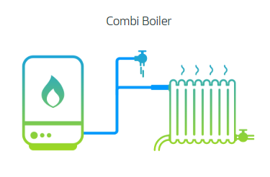

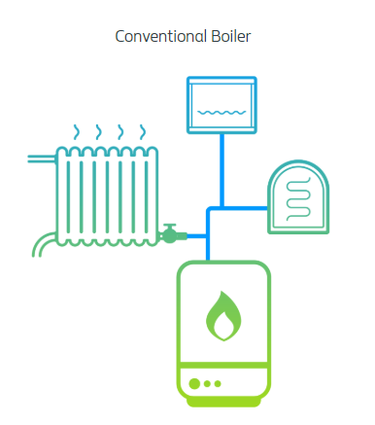

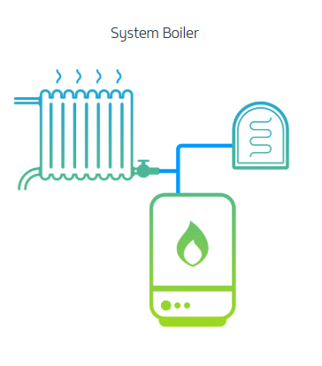

**What size of boiler do you need?**

This will depend on a few things:

How much water do you use?

Large family homes are more likely to use more hot water than a one bedroom flat. Your energy consultant would calculate this for you and give you the best and most energy efficient option.

How much space do you have?

If you’re pushed for space in your home, combi boilers are a good option since they don’t require a hot water cylinder

Where do you want the boiler to live?

If you’re replacing an old boiler, its usually best to put the new one in its place. The boiler can be placed anywhere within reason, as long as theirs appropriate pipework and flu access.

**What fuel should I use?**

There are a range of fuel sources to heat your home. Mains gas is most common in suburban areas, but your area might not have a mans gas connection. If not, we can help you choose the right option for your home, such as LPG, Oil or Electric heating.

**How should I control my heating?**

With so many options out there, it can be hard to think about how you’d like to control the heating schedule in your home. We can offer you a range of traditional thermostats to app based zone control systems and help you chose the right one for you.

Radiators, Towel Rails & Underfloor Heating

**Get in touch for a free survey here**

Have you thought about renewables to heat your home? **Click here to find our more.**